Unit 02 Lecture Notes

Day 1
- In the last units of Python course, we looked into creating Classes, define behavior and methods. This Unit, we are going to do similar task but using Java.
- Slide 4 – Noun Verb Analysis
  - In OOP, we don’t write on monolithic class which include all functionality
  - Instead we create multiple classes, to support different functionality and these classes interact with each other to solve large problem.
  - Question comes how do we know what class to create
    - Noun verb analysis
    - Must do before jumping on writing the code.
    - Many nouns (not all) becomes classes, other will become attribute
    - Verb typically translates to methods
  - There will be one specific Noun which will describe the entire applications. This class typically have the main method [ Talk that not all class will have main method ]
  - E.g. MyCourses Entire application
    - Student -> Class
      - Attributre -> Name, email, etc
    - Support Staff
    - Course Content
  - When designing the system and trying to identify Classes/Attribute/Methods, Limit yourself to what is being asked in the requirement. Don’t add assumptions.
    - Transaction -> Master card, Don’t add support for Debit card etc.

- Activity 2.1 -> Do noun verb analysis
- Slide 6 - 7 – Fields
  - Class is a blueprint, which defines what is object is going to do
  - Fields defines the state of an object -> e.g. Car Stopped, Moving, Turning etc.
  - In python, a dynamic class where we can add variables dynamically, we used __slots__ to define what variables can be added to the class.

Car Speed 0 stopped, > 0 – Moving
Turn Turning

Java does not have slots. Instead we add fields to the class. No dynamic addition of fields.

- Slide 8 – Object instantiation
  - Class is a blueprint, it defines the attribute and behavior of an object. What it can’t be used directly.
  - In order to use the class, you have to instantiate it.
  - House house = new House();
  - Above Syntax instantiate and allocate memory for each attribute
  - Talk about default constructor();
- Slide – 9 Activity 2.2
  - Create weapon class with following attribute
    - Name, Damage Type with public access.
  - Create StarWarBattle class and create instance of weapon
    - Create Weapon instance and set values.
    - Show how it is possible to set invalid values for damage amount.

- Class vs Object
A class is a template or blueprint that defines:
- Properties (variables / fields)
- Behaviors (methods)
It does not occupy memory for data itself—only the structure is defined.

Object (Instance)
An object is a real instance of a class.
- Created using the new keyword
- Occupies memory
- Can access class methods and variables

- Slide 10 – Package..
  - Namespace for logical grouping.
  - Mostly for organization of code so that you don’t have large amount of class in one folder.
  - There is strong co relation between package name and folder structure in file system.
  - If multiple folder are nested then . is used to separate the package names.
  - May be do some example..
- Slide 11 – Package Scope
  - Scope refers to the parts of a program in which an identifier is visible.
  - Talk about different scope
    - Local variable declared within {}
    - Instance level scope of field to entire class
    - Method scope entire class
  - Package scope
    - Class within same package, no import is needed.
    - Class from outside package, need import statement like Scanner
    - By default java import java.lang package so you don’t need to import these.
  - Move classes to swb folder.
- Slide 13 – Constuctor
  - Talk about default constructor all instance variables are assigned default value.
  - Initialization can be done in constructor
  - Python, we used self to associate a parameter to the class.
  - In java, we must define instance level variable (no dynamic type)
  - No self option.. In java to access instance variable, we use this keyword. NOTE: THIS is not needed, it is to reduce ambiguity between instance variables and local variables.
  - Constructor do not have return type and have the same name as Class name.
  - Define a default constructor and initialize variable.
- Slide 17 -> Create ship class
  - Talk about non- default constructor
  - Default constructor goes away
- Slide 18 -> Override & constructor
  - Unlike python -> Java does not have default value of parameter.
  - Instead we define multiple method with same name but different set of parameter.
  - Constructor can be overloaded as well.
    - Do an example of constructor overload.
    - Show you can instantiate only using constructor which you create.
    - Show how you can create call other constructor as well
      - This(abc,bcd)
      - Must be first call in the constructor.

- Slide 20 – Encapsulation
  - Bundling fields and method inside single unit called Class.
  - When you instantiate, each object has its own copy of data and methods.
  - Change in state of one oject does not have any impact of other object.
  - Important points
    - Ensure that fields you are defining are related to each other
    - Also the methods defined uses one or more of these fields.
  - Promotes reusability.
- Slide 21 – Encapsulation contd.
  - Access control to the attributes
  - You want to prevent invalid values from being set. Like ship shield being negative.
  - To achieve that we use following access modifier
    - public – grants access to all parts of the program.
    - protected – grants access to classes in the same package and child classes (we'll talk about this more in the next unit).
    - private – grants access to objects of the same class.
    - <none> - grants access to other classes in the same package but not child classes. Also known as "package private."
  - Acess modifier at class level
    - public✅ YesAccessible from any package
    - protected❌ NoNot allowed for top-level classes
    - private❌ NoNot allowed for top-level classes
    - no specifier (default)✅ YesAccessible only within same package
    - Java does not allow private or protected on top-level classes
    - Reason:
    - A top-level class must be visible at least to its own package.

  - Access modifier at constructor level

public Constructor 🌍
- Object can be created from anywhere
- Most common

private Constructor 🔒
- Object cannot be created outside the class
- Used for:
  - Singleton pattern
  - Utility classes
  - Factory methods

protected Constructor 🧬
- Accessible:
  - Same package
  - Subclasses (even in different packages)

Default (No Specifier) Constructor 📦
- Accessible only within the same package

  - State (fields) should be private and accessed or modified only as needed using public methods.
  - Protecting fields from being manipulated by other parts of the program is referred to as data privacy.

- Slide 22 – activity 2.7
  - Mark Weapon class field to private
  - Now you have to define accessor or modifier
- Slide 23 – Talk about accessor and modifier
  - Add accessor and modifier only if needed.
  - Only add mutator or access if other class need to access it. It prevents the state of an class being set to ineligible value or exposing information.
  - Specially careful in the case of mutator. Sometime delay implementing till it is really needed.
- Slide 24 – Activity – Define accessor and mutator
- Slide 25 – enumeration.
  - an enum type is a special data type that enables a variable to be a set of predefined constants.
  - Sometimes a variable should only be assigned one of a specific set of predefined values, such as days of week, month of a year.
  - Options are assign a numeric value to each value – 0, 1
    - Assign text “Jan”, “Feb”etc.
    - Approach is error prone.
  - Java provide an emumration type called Enum
    - The values that may be assigned to the type are explicitly enumerated using a comma-separated list of names.
    - The values that may be assigned to the type are explicitly enumerated using a comma-separated list of names.
    - Advantage
      - More natural
      - No error or confusion

- Slide 27 – Complex enumeration type
  - Sometime we want to associate additional values to the enumeration type.
  - To achieve
    - Add additional field inside enum to store the value.
    - Define private constructor to initialize the value for default or use parameter to pass the value. [Java allows only private constructor]
    - Define accessor
    - Might have other methods as well.
  - Enum name() method returns the Text assign to the enum values.
- Slide 31 : Special method toString()
  - toString() method is automatically called when you try to print or concat or any activity which require string representation of object
  - By default it prints name of class + some additional information.
  - It is beneficial to write your own implementation.
  - Add @override attribute.
  - You basically override with your own implementation and it is called overriding.
- Slide 33 – equals method
  - For Objects, == does not work. It compare the address of the objects.
  - .equals() must be used for object for deep equality
  - In general you will want to use equals instead of == when working with non-primitive objects.
  - In equals() method, two instances of the same class can directly access each other's private fields without using an accessor.
  - While doing equality, first make sure that they are of same type before comparing the other fields.
  - Use @override annotation.
- Slide 37 – Pattern matching with instanceof
  - Talk about using instance of pattern matching
  - It is available after java 16 and above.
  - Starter code has source set to 11. It should be set to 23 or what ever latest is on user desktop
<plugin>
<groupId>org.apache.maven.plugins</groupId>
<artifactId>maven-compiler-plugin</artifactId>
<version>3.8.0</version>
<configuration>
<release>23</release>
</configuration>
</plugin>

- Slide 38 – Operator overloading – special methods
  - Java does not support operator overloading.
  - There is no special method called __lt__ etc.
  - Java uses something called comparison/comparator to sort data in specific order. Will discuss more in
  - Similar to python __hash__, java does have an equivalent method. We will discuss while discussing
- Slide 39 – Additional Enumeration features
  - toString() default returns name of value can be overwritten.
  - name() also returns name of value
  - valueOf(String) returns corresponding Enum. If not defined then it throws error.
  - Values() all the enum values as array of enum i.e. DamageTypes[]
- Slide 40 Do the activity.
- Slide 41 Static Modifier
  - Global instance of corresponding method or variable
  - Applies to method or variables
  - Static item is part of class. Accessible using ClassName.static member.
  - If changed, then changed globally.
  - An static method can only access static method and fields. That is the reason we have been creating method with static modifier.
  - You should not make a non-static method static just so that it can be called from a static method.
  - Avoid using Static.
- Slide 42 Final and Constant
  - The final modifier indicates that, once a value has been assigned to a variable, the value may never be changed.
  - Constants are both static and final and may also be public if they are needed outside of the class. i.e. PI.
  - Using constants makes it much easier to change the value. For example, if we need to add 3 more digits of precision to Pi, we only need to change it in one place.
  - DON’T HARD CODE VALUE. DEFINE AS CONSTANT – i.e. PI VALUE.
  - Probably create a constant files and Define constants there.

Day 2

- Do the introduction to draw.io
- Slide 49 – UML Relationship.
  - UML is used to describe the relationships that exist between classes.
  - A relationship between two classes indicates that the classes use each other in some way.
  - Relationships are represented using a line that connects the two classes. The lines may be solid or dashed.
  - Relationships may also include an arrow that indicates directionality. It is very important to use correct directional component.
  - We build UML diagram before code writing.
- Slide 49 – UML relationship
  - Relationship is defined using lines connecting shapes using solid or dotted lines. Some of the lines ends with arrow which indicates directionality.
  - If there is no arrow, the relationship is undirected meaning that the classes use each other.
- Slide 50 – Basic UML relationship
  - A -------------- B-- Solid line -- Association A has B but not other way -
  - A ------------- B – dashed line – Weak association A is using B as an argument or variable scope. But B is not a field in A
  - A -------------- B – No Arrow Both A and B has each other.
  - Also talk about one to many relationships.
- https://www.softwareideas.net/class-diagram-enum --> For enum representation
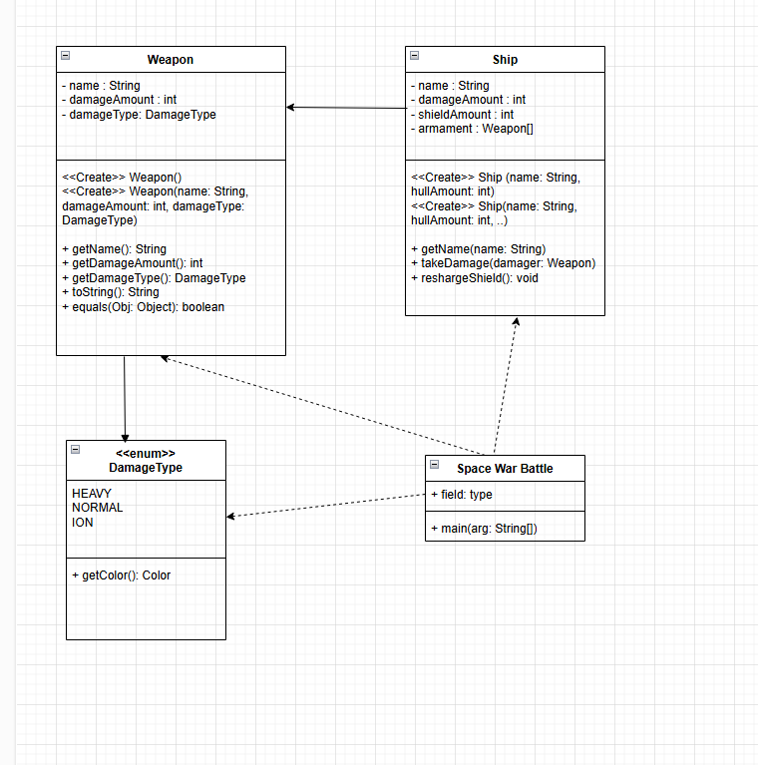
- SKIP Slides to go to 56
  - Talk about other comments tag such as //, /* */
  - Talk about java doc
  - Talk about different tags. @author @since etc.
  - Method tag @param @return etc.
- Step for generating Javadoc
Adding following line in pom file
<plugin>
<groupId>
org.apache.maven.plugins
</groupId>
<artifactId>
maven-javadoc-plugin
</artifactId>
<version>
3.11.2
</version>
<configuration>
</configuration>
</plugin>

https://maven.apache.org/plugins/maven-javadoc-plugin/usage.html

Google Search for “maven project javadoc plugin usage”
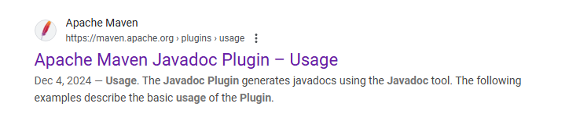

After that run the following command
mvn javadoc:javadoc

- Slide 58 – String parsing
  - Trim()
  - Split() – “” – each character – “ “ – spaces, “[.]” based on period.
  - Equals()
  - Substring()
- Slide 60 – Random
  - Provided as part of package java.util. Class name Random
  - Random rnd = new Random(); --without seed
  - Random rnd = new Random(100); --with seed
  - Rnd.nextInt(50,100); generate number between 50 and 99.
  - Rnd.nextInt(100); from 0 to 99
  - Other methods are nextBoolean(), nextFloat() etc.
- Random function is pseudo random. With a specific seed value, it will generate same sequence of random number.
- Slide 62 – Objects.
  - every reference type is related to the java.lang.Object class
  - instances of any class can be assigned to or used as arguments and return values where Object is declared as the type.
  - When a primitive type is assigned to object, it is converted to corresponding class
    - Object abc = 10; -> abc.getClass() -- Integer etc.

- If time permits, perform slide 50 to 55 Years hands on.

Teaching Steps

- Start with basic introduction of Classes as we did before
- Give 5 minutes to students to come up with Noun and Verbs
- Talk about
- Create Weapon class with all public instance variable in unit02 folder.
- Create SpaceWarBattle Class with main method unit02 folder. Create instance of Weapon and print its values.
- Talk about packages. May be create some temporary packages and add java file.
- Create SWB package and put above two files there.
- Talk about package scopes – SLIDE 11
- Talk about constructor
  - Default constructor
  - Create default constructor Weapon and show how it is called when Weapon is created.
  - Modify default constructor to initialize instance variable
  - Talk about how when you create non default constructor, default constructor is no longer there
  - Now Name is required, how do I force it.
  - Create Weapon constructor with name, damageAmount, damageType.
  - Create Weapon constructor with name and call previous constructor using this variable.
  - Unlike python, Java allows multiple constructor.
  - Constructor OVERRIDE. JAVA ALLOW MULTIPLE METHODS WITH SAME NAME AS LONG AS # OF ARGUMENT AND TYPE IS DIFFERENT.
- Create SHIP Class
  - HOLD ON TILL WE COMPLETE THE OTHER ITEMS. – SKIP SLIDE 19 also
- Talk about Encapsulation as well as Scope/Data Privacy
- Make all fields in the Weapon class as private. SpaceWarBattle will not compile any more.
  - Talk about Getter and Setter method.
  - Update Weapon class to set getter and setter.
  - Not all method require setter.
- Now work on completing Ship Class.
- Enumeration :
  - Talk about issue with variable with different fixed values.
  - Declare an enum with DamageType
  - Replace the Weapon damage type data type. Change other class to make the code compile
  - Discuss how to add Color attribute to it.
- Special Method – toString()
  - Add toString to Weapon, Ship and DamageType
  - Print it and show.
- Special Method – equals()
  - Add equals method to Weapon and Ship
- Slid e38 - Talk about other special method not supported in Java.
  - Java does have support for hashing but discuss in later units
  - Lt, gt etc are not supported. Sorting is done using implementation of comparator objects which we will discuss later.
- Slide 39 – More about enums
  - Name()
  - valueOf(String) gives enum
  - values() array of enum values.
  - May be introduce students to new for loop for array

Day 2
- Talk about pattern matching of instance of (Weapon class)
- Work on Ship Class and do some exercise in StarWarBattle.
- Slide 41 – Static Modifier
  - Talk about being Part of class. Only one copy shared across instances
  - Can’t access instance method. DON’T MAKE STATIC METHODS
  - Avoid using static.
- Slide 42 – Final & Constant
  - May do circle example
  - Do final exercise of putting ship and weapon name as constant.
  - Create Constants.java and Add all constants there.
- Slide 44 - Do UML Diagram
  - Draw.io
  - Talk about how class is defined
  - Talk about how relationship is defined - Slide 50
- SKIP Slide 52 – 56 – Hands on
- Slide 57 – Java Doc document generation
- Slide 58 – String parsing
- Slide 60 – Random()
- Slide 62 – Object()

